IMM 5707 - SAMPLE DOCUMENT OF FAMILY INFORMATION FORM

Keerthika Veeramani (Cognizant)

COGNIZANT TECHNOLOGY SOLUTIONS [Company address]

**General instructions for Family inform form.**

* The above instruction are pointed out for primary applicant family information form of Section A and Section B.
* If you are going to process for spouse , you need to fill separate family information form under spouse name as Applicant and Spouse father and mother details needs to be entered.
* If you are going to process for child, you need to fill separate family information under child name as primary applicant and all others details have to be given.
* This form needs to be signed by all the applicants who are travelling with primary applicant for your children, this form needs to be signed by primary applicant
  1. Application is submitted as **self only and applicants marital status as unmarried,** then this form needs to signed in section A, B & C
  2. Application is submitted as **self only and if applicant marital status is married with no children** then this form needs to be signed in section B & C
  3. Application is submitted as s**elf only and if applicant marital status is married and have children** then this form needs to be signed in section C only.
  4. In **spouse family information form** spouse needs to place his/her signature in section C. If there are **no children** then spouse needs to sign in Section B & C
  5. In Child form primary applicant needs to place his/her signature in section A, B & C

**Family information form-Sample Instruction**

# Section – A

**TYPE OR PRINT IN BLACK INK**

1

1

5

4

3

2

1. Update the primary applicant given name AND Family name as per the passport.
2. Update the marital status as applicable in dropdown. In the marital status if you are, selecting Married then another box appears for you to choose physically present it means your spouse was physically present with you at the time of marriage. If you are, selecting married not physically present means the marriage happened through online.
3. Update the date of birth in YYYY-MM-DD.
4. Update the Country of birth as applicable. (Example – India)
5. Present Occupation Update the current designation as per HCM in full expansion. (Example – senior associate – projects).

13

7

7

10

9

11

12

8

**Q6**-Mention your current stay address.

**Q7**-Update the spouse name as per the passport (if married)

**Q8**- Update the date of birth in YYYY-MM-DD

**Q9**- Update the marital status as applicable in dropdown.

**Q10-**Update the Country of birth as applicable. (Example – India).

**Q11-**Mention Spouse current stay address.

**Q12-** If your spouse and parents are not working, please update the current designation as unemployed but not home maker.

**Q13-** If spouse accompanying with primary applicant mark as yes, if not travelling, then click on NO Check box.

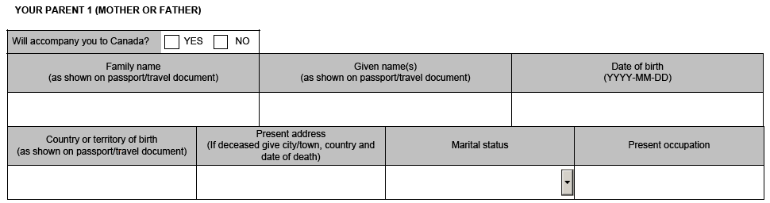

13

14

14

16

15

17

18

19

**Q14 –** update Mother and father name separately in both the tabs**. Q15-** Update the marital status for both father and mother.

**Q16-** Update date of birth for Mother and Father separately in both the tabs in YYYY-MM-DD format.

**Q17-** Update the Country of birth as applicable. (Example – India).

**Q18-** Update Mother and Father current stay address in both the tabs.

**Q19-** Present occupation for Father -mention his current business or current job profile or retired. Present occupation for Mother -mention her current business, profile or retired or Home Maker. Present occupation for Father -mention is current business or current job profile or retired.

If you’re Mother or father is deceased, then mention the deceased city/town, Country and the date of death in Present address tab.

Just mention as Deceased under Present Occupation tab.

**Q-20** Click on NO check box for both father and mother by default

# Section - B

# 

# Children – Include all sons and daughters –including all adopted and step children.

28

21

21

24

27

22

26

23

25

29

**Q21**-Update Child name as per his/her passport.

**Q22**- Update the marital status as per the drop down. **Q23**- Update the relationship. For e.g. – (Son/ daughter) **Q24.** Update the children’s date of birth in YYYY-MM-DD.

**Q25-** Update the Children’s Country of birth as applicable. (Example – India, US).

**Q26-** Update Children’s current stay address in both the tabs.

**Q27**-Update the present occupation of child as (Studying, toddler or NA) as applicable.

**Q28-** If child is accompanying with primary applicant mark as yes, if not travelling, then click on NO Check box.

**Q29-**If no children then check mark the box